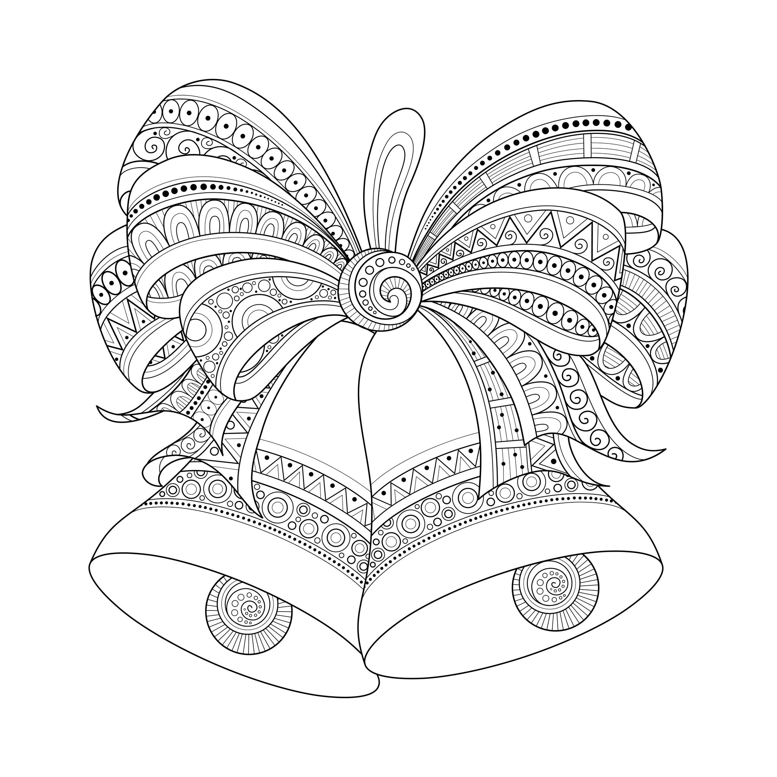

Name: _______________________________________
Bandon School District 2016 Coloring Contest
Foot Loose and Stress Free Wellness Program

